Week 9 - NiFi

Objective 1 - Conceptual Foundations
Apache NiFi is a dataflow platform designed to move data between systems, transform it along the way, and provide visibility and control over the entire process. It can ingest data from many sources—files, APIs, IoT devices, and more—and connect them through visual, flow-based pipelines. Instead of writing scripts, you drag processors onto a canvas. Each processor performs a single task (such as ingesting, cleaning, or routing data). Data moves through the system as FlowFiles, which contain both the raw data and metadata like filename, source, or device ID. This visual approach makes it easy to monitor, throttle, and scale pipelines even when sources and destinations are very different.

NiFi commonly supports ETL workflows (Extract, Transform, Load). “Extract” pulls data from sources, “Transform” reshapes it (for example, converting CSV to JSON), and “Load” sends it to targets such as HDFS or SQL databases. What sets NiFi apart from many ETL tools is its real-time, streaming nature and built-in observability. Instead of running nightly batch jobs, NiFi can process data continuously as it arrives, with backpressure, prioritization, and live monitoring built in.

A practical example is healthcare device integration. Apple Watches and Fitbits produce different data formats, but hospitals may require everything in a standard format like CSV. NiFi can ingest the incoming JSON and raw device data, normalize it, and output a unified format. This allows multiple data sources and schemas to be combined into a single, consistent stream that downstream systems can easily consume.

Objective 2 - Environment Initialization

After connecting via SSH and logging in, we’re now inside the NiFi UI. From here, we can create process groups and processors to build and visualize NiFi’s dataflows.
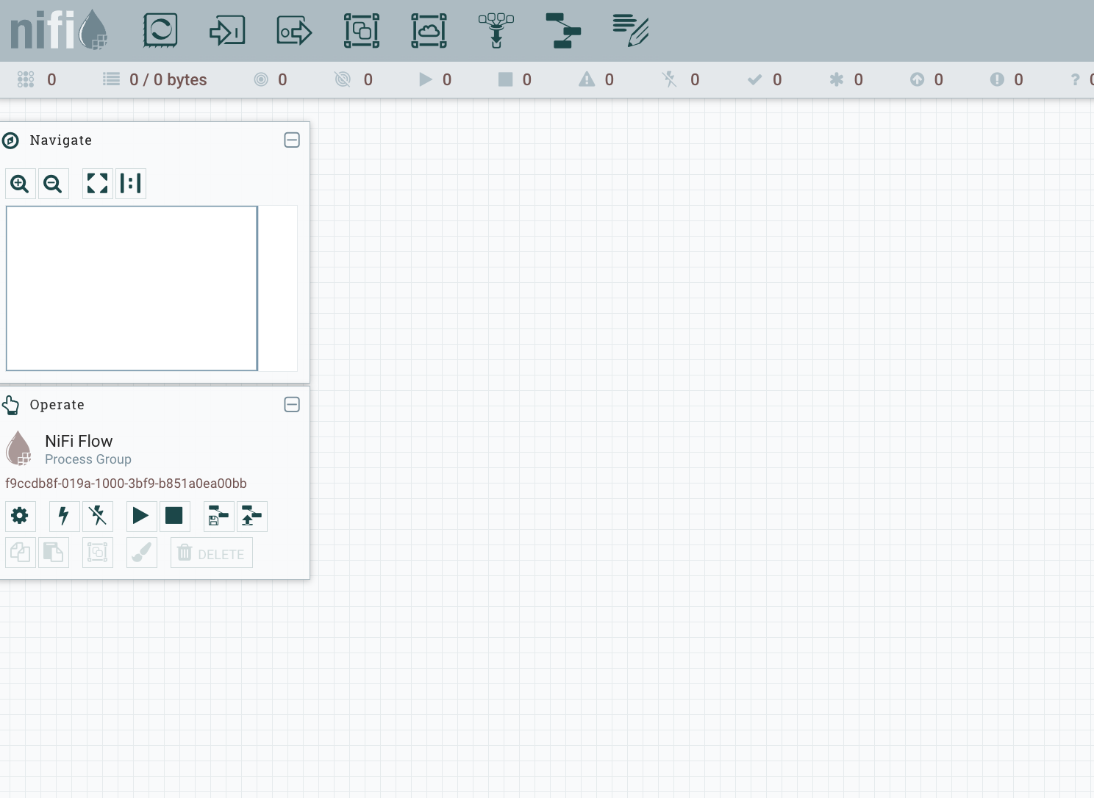

Objective 3 - Creating a Processor Group and Context

For our first process group, we created a custom flow that generates a file every few seconds. We use parameters to control things like the schedule and file size. In this example, we emit a 2 KB file, but we can easily change it to 1 KB and immediately see the size update in the dataflow.

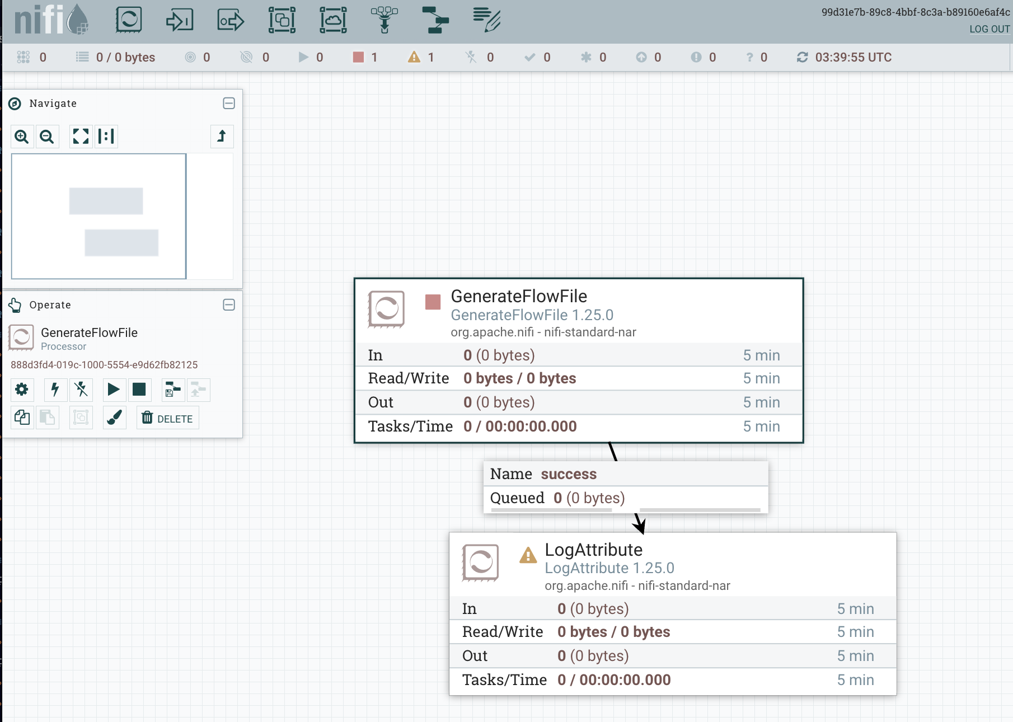

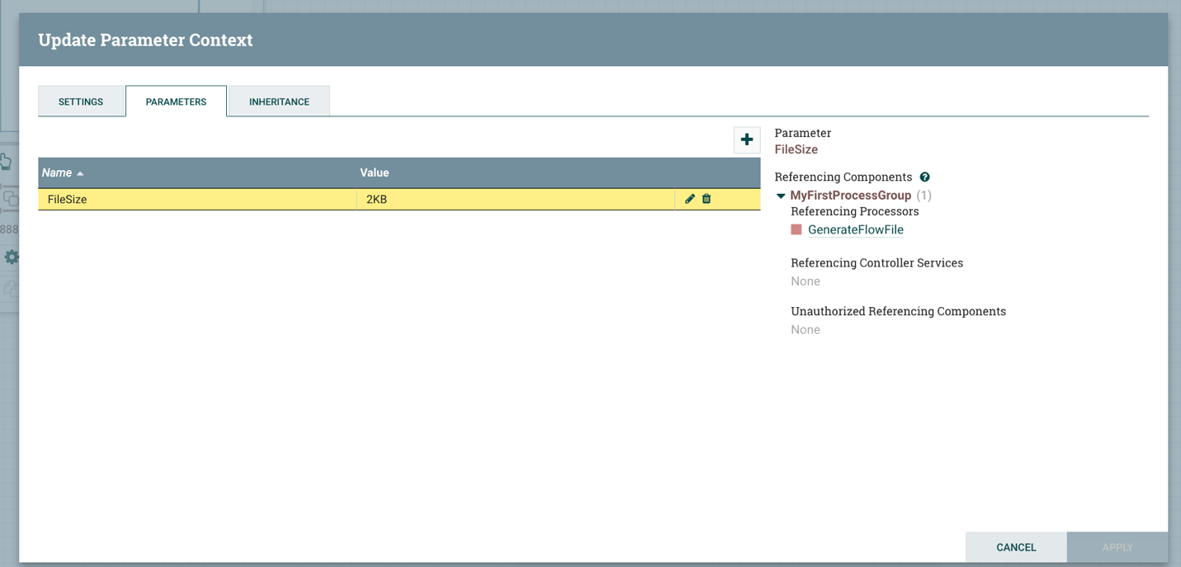

Objective 4 - Designing a Simple Flow

Using the log attributes provided in the course materials, we created a process group that aligns with the target schema for data ingestion. This demonstrates the ability to build process groups manually while also highlighting the advantages of pre-populated process group configurations and reusable subprocesses for faster, more consistent pipeline development.

Objective 5 - Setting Up Solr Collection

The syslog Solr collection was successfully created and is now accessible by Apache NiFi for data ingestion and retrieval. This collection will be used to store and index processed syslog events from the NiFi dataflow, allowing log data to be queried, analyzed, and visualized as structured records throughout the assignment.

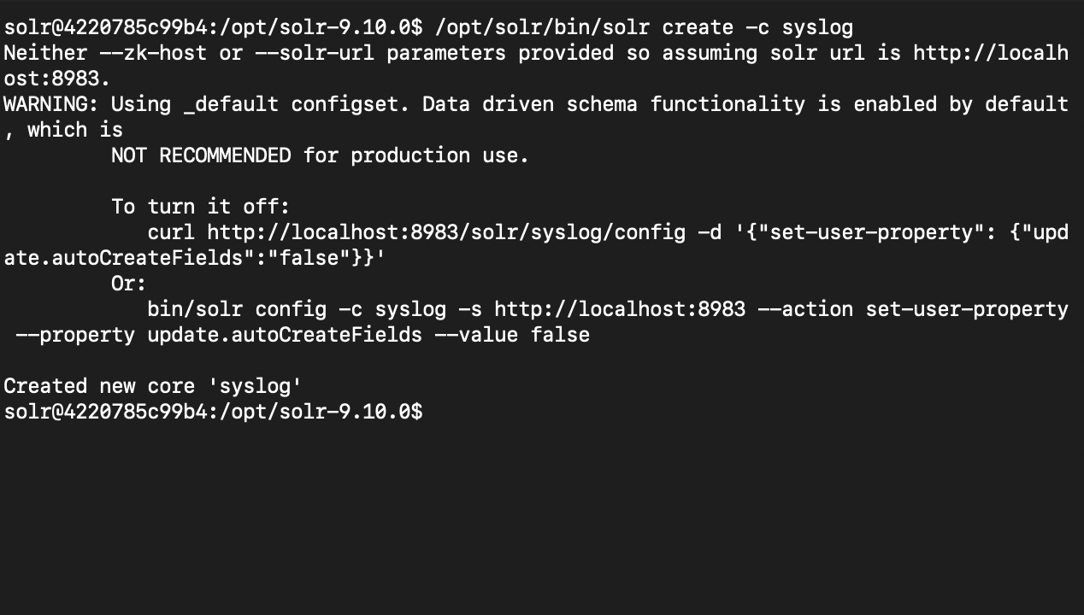

Objective 6 - NiFi Advanced Flow with Solr Integration
The running NiFi flow confirms that syslog events are being generated, filtered, and successfully written into Solr. The visible documents in Solr verify end-to-end pipeline functionality—from data creation in NiFi to indexed, searchable records in the syslog collection.

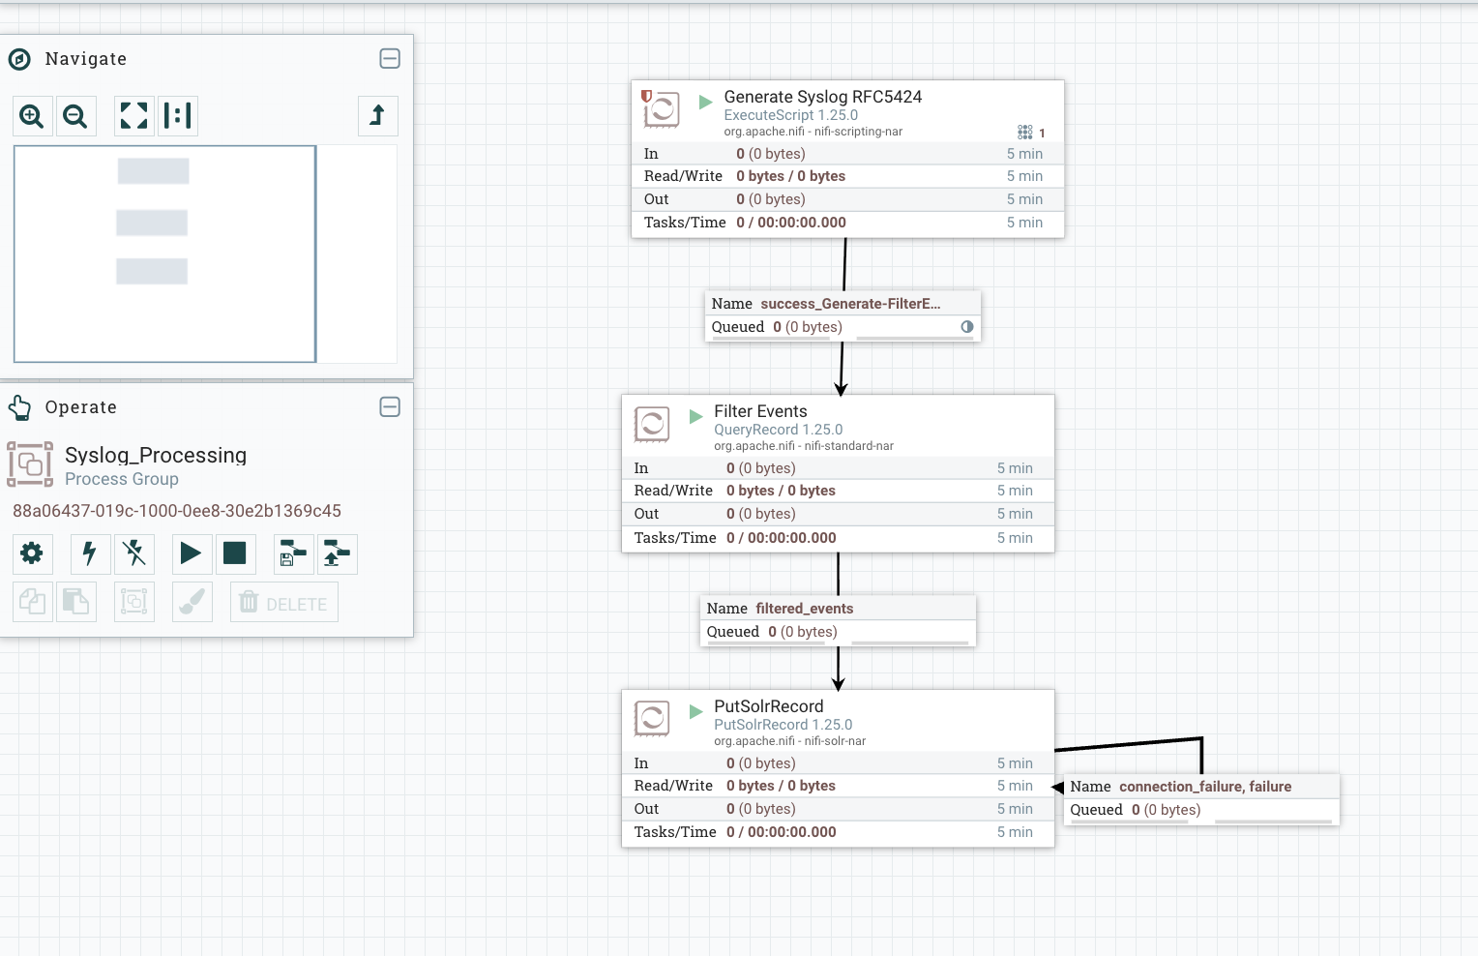

Objective 7 – Querying Solr Data

Using Solr, we run a wildcard query (`q=*:*`) against the `syslog` collection. Instead of an empty result set, the index is now populated with parsed syslog events produced by the NiFi dataflow. The response returns 10 documents, each containing structured fields like timestamps, hostnames, severity levels, application names, and message bodies—confirming that the pipeline is successfully transforming raw logs into searchable records.
